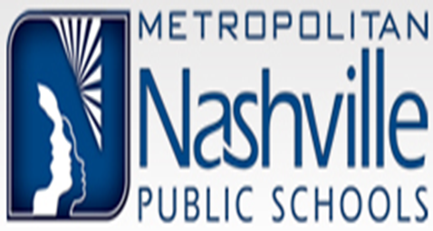
2601 Bransford Avenue
Nashville, Tennessee 37204
(615)259-8732 P (615)291-6098 F

- How do I get a copy of my child’s educational record? He/she is currently enrolled in MNPS.
You may go to the school your child is attending and request it from them directly.

- How do I get a copy of my transcript?
The requestor must complete the “Record Request Form” if the requestor is eighteen (18) years old or older, or if the requestor has been out of school for a period of four years. Students who graduated or attended in the last three years should contact the school directly. There are menu options on the request form and the fee charged with the option you choose. The return address is printed on the request form. Please submit a photo I.D. along with a money order payable to MNPS. You may also make your request in person at the Family Information Center. They accept cash, debit, & credit cards for payment. Please allow a minimum of ten business days to process.

- Can my transcript be faxed or picked up?
No, transcripts must be mailed.

- Do you accept debit & credit cards for transcript fees?
Yes, we do accept debit and credit cards.

- I don’t have a Driver’s License. What other kinds of ID can I use?
State ID, Passport, & Military ID

- I’m over the age of eighteen. Can my parent request my record?
Yes, we require a written consent from you, your signature and a photo ID.
The parent must also provide their I.D. when making the request. Please refer to the
Consent for Release Form.

- How can I get a copy of my ACT/SAT Scores?
Your test scores are usually included along with your transcript, provided you took the test(s) while you were in school. If your high school cannot provide your test scores, you can contact the Testing Boards directly for assistance.
ACT: http://www.act.org or call 319-337-1313
SAT: https://www.collegeboard.org or call 212-713-8000

- How do I get a copy of my high school diploma?
Contact the Department of Education
ATTN: Duplicate Diplomas
10th floor, Andrew Johnson Tower
710 James Robertson Parkway Nashville, TN. 37243
Phone 615-532-4867 http://tn.gov/education

- How do I get a copy of my G.E.D. Diploma?
You may request it from diplomasender.com

- I have a subpoena requesting school records. Can I serve the subpoena to the
Records Center?
Yes, we are open from 8:00 until 4:30.

- Do you have student yearbooks?
We do not have student yearbooks at the Record Center.

